Admin

1. Customer / Vendor GSTIN Details missing from Dashboard, below screen prints for your reference:

Link in Admin

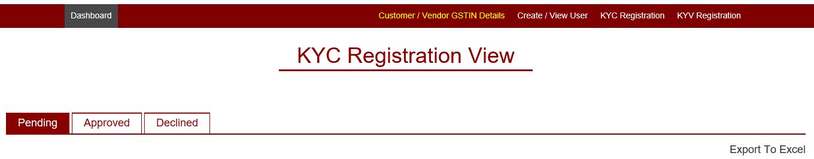

Screen

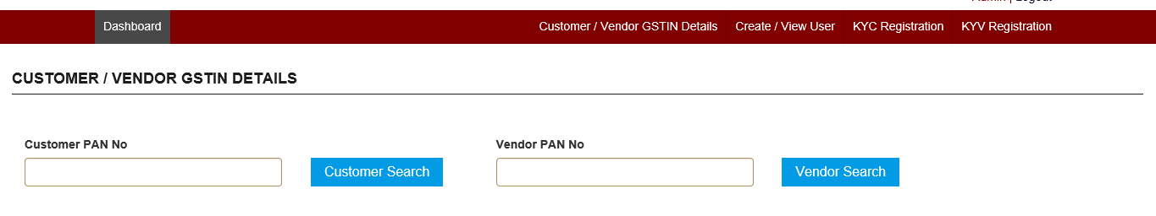

Output of Screen

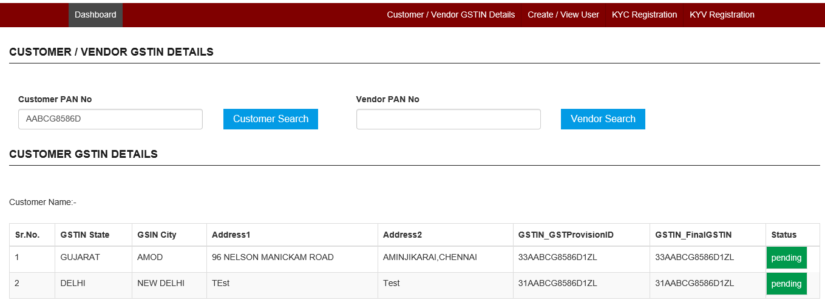

1. Below error is encountering on click of Create / View User link in Dashboard.

