**User End**

KYC

1. Mail not received on submission of KYC to customer.

KYV

1. Check the above issue exist or not, if exist correct the same
2. Not able to submit KYV even though bank details are filled and file is uploaded, below screen print for your reference:

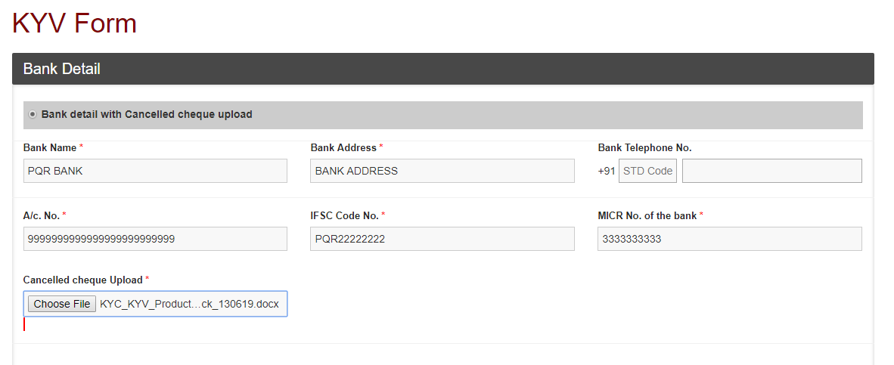

**Admin End**

1. Customer / Vendor GSTIN Details screen both the “Search” buttons not giving result

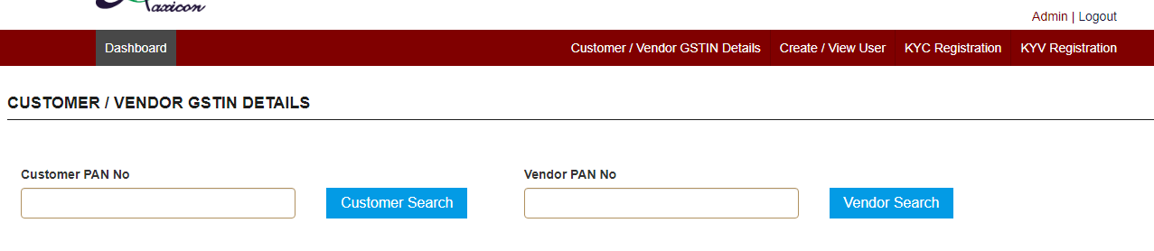

1. KYC Registration: Validation of GSTIN selection is missing while click on “Accept” and “Decline” button.
2. Decline Mail not received after declining KYC
3. Declined record showing in Decline Tab but GSTIN record showing as approved, below screen print for your reference:

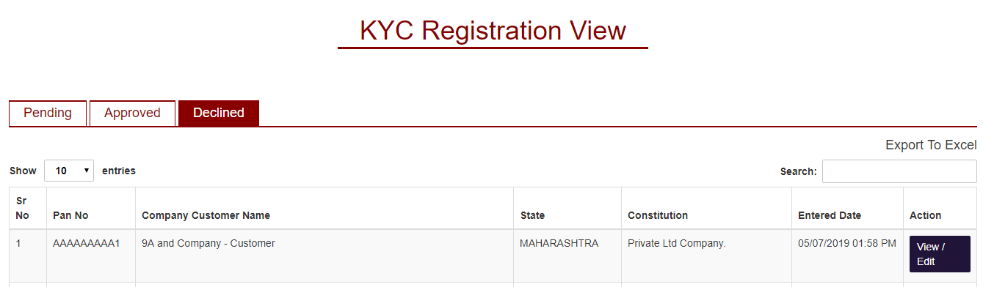

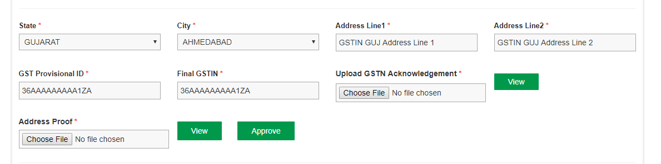

**Note: Errors mentioned for KYC to be reviewed for KYV too.**